Golden Harmony Theory Integration

The Golden Harmony Theory enhances our understanding of resonant harmonics by incorporating the principles of balance and efficiency. Key components of GHT include:

1. Resonance (R): Identifying and optimizing optimal patterns within the system.

2. Fuel Efficiency (F): Ensuring efficient utilization of resources.

3. Energy Conversion Efficiency (E): Optimizing the conversion of inputs into outputs.

4. Golden Ratio (Φ): Utilizing the Golden Ratio to achieve natural balance and harmony.

# Mathematical Framework

The mathematical framework of resonant harmonics can be described using the following equations:

1. Harmonic Series:

where (fn) represents the nth harmonic frequency, and (f0) represents the fundamental frequency.

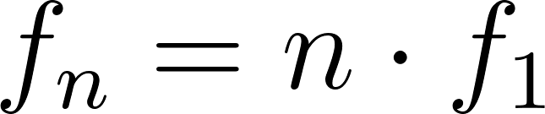

2. Resonance Condition:

where (A) represents the amplitude, (ω) represents the forcing frequency, (k) represents the stiffness, (m) represents the mass, (ω0) represents the angular frequency, and (b) represents the damping coefficient.

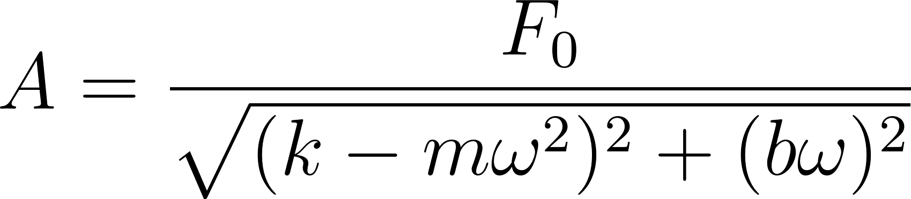

3. Wave Interference:

where (y) represents the resulting wave amplitude, and (y1) and (y2) represent the individual wave amplitudes.

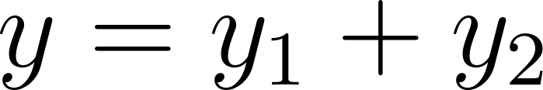

Golden Harmony Theory Integration:

The Harmony Equation is redefined to incorporate the Golden Ratio as follows:

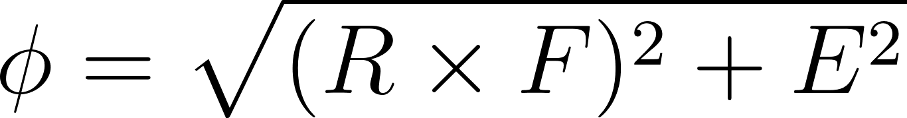

where:

- (Φ) represents the Golden Ratio ((Φ)).

- (R) denotes Resonance.

- (F) represents Fuel Efficiency.

- (E) stands for Energy Conversion Efficiency.

Furthermore, the equation can utilize various mathematical constants such as π (Pi), φ (Phi), and e (Euler's Number) depending on the field and specific application. The selection of the appropriate constant ensures the equation's efficacy in achieving the desired results.

## Lab Simulations Conducted with Julius AI

These are lab simulations ran with Julius AI as examples of the work.

### Lab 1: Microwave Frequencies in Water

**Objective**: Observe the effect of microwave frequencies on the molecular structure and properties of water.

**Setup**:

1. Materials:

- Water samples

- Frequency generator

- Sensors to measure molecular changes

2. Procedure:

- Apply varying microwave frequencies to the water samples.

- Monitor changes in molecular structure and properties.

3. Equations:

Resonant Harmonics:

approximitly

Where f_n is the nth harmonic frequency, and f_1 is the fundamental frequency.

- **GHT Integration**:

\phi = \sqrt{(R \times F)^2 + E^2}

Where Phi represents the Golden Ratio (approx 1.618), R denotes Resonance, F represents Fuel Efficiency, and E stands for Energy Conversion Efficiency.

### Lab 2: Microwave Frequencies on Plant Growth

**Objective**: Assess the impact of microwave frequencies on the growth and health of plants.

**Setup**:

1. **Materials**:

- Plant samples (e.g., seedlings)

- Frequency generator

- Growth monitoring tools

2. **Procedure**:

- Expose plants to microwave frequencies.

- Track growth rate, leaf color, and overall health.

3. **Equations**:

- Resonant Harmonics:

A = \frac{F_0}{\sqrt{(k - m \omega^2)^2 + (b \omega)^2}}

Where A is the amplitude, f_1 is the forcing frequency, k is the stiffness, m is the mass, Ω is the angular frequency, and b is the damping coefficient.

- GHT Integration:

phi = sqrt{(R times F)^2 + E^2}

### Lab 3: Microwave Frequencies in Tissue Repair

**Objective**: Investigate the effect of microwave frequencies on tissue repair and regeneration.

**Setup**:

1. **Materials**:

- Tissue samples

- Frequency generator

- Healing monitoring equipment

2. **Procedure**:

- Apply microwave frequencies to tissue samples.

- Monitor the rate and quality of tissue repair.

3. **Equations**:

- Wave Interference:

y = y_1 + y_2

Where y is the resulting wave amplitude, and y_1 and y_2 are the individual wave amplitudes.

- GHT Integration:

phi = \sqrt{(R \times F)^2 + E^2}

### Lab 4: Microwave Frequencies on Metal Fatigue

**Objective**: Examine how microwave frequencies affect metal fatigue and structural integrity.

**Setup**:

1. **Materials**:

- Metal samples

- Frequency generator

- Stress testing tools

2. **Procedure**:

- Subject metal samples to microwave frequencies.

- Monitor changes in metal fatigue and structural integrity.

3. **Equations**:

- Resonance Condition:

A = \frac{F_0}{\sqrt{(k - m \omega^2)^2 + (b \omega)^2}}

- GHT Integration:

phi = \sqrt{(R \times F)^2 + E^2}

### Lab 5: Microwave Frequencies in Air Quality

**Objective**: Determine the impact of microwave frequencies on air particles and overall air quality.

Setup:

1. **Material**:

- Air samples

- Frequency generator

- Air quality sensors

2. **Procedure**:

- Expose air samples to microwave frequencies.

- Measure changes in air particles and overall air quality.

3. **Equations**:

- Harmonic Series:

f_n = n \cdot f_1

- GHT Integration:

\phi = \sqrt{(R \times F)^2 + E^2}

## Applications of Resonant Harmonics with GHT

Resonant harmonics, enhanced by the Golden Harmony Theory, find applications in various fields, including:

**Acoustics**: Understanding musical instruments and sound engineering. GHT facilitates the optimization of resonance patterns for achieving clearer and more harmonious sound.

**Mechanical Engineering**: Designing structures and machinery to mitigate resonance-induced failures. GHT ensures efficient utilization of materials and energy.

**Electronics**: Tuning circuits and filters for optimal performance. GHT aids in achieving balance and efficiency in signal processing.

**Medical Imaging**: Enhancing the resolution of ultrasound and MRI techniques. GHT improves the efficiency of energy conversion in imaging systems.

**Environmental Science**: Monitoring natural frequencies of ecosystems and predicting environmental changes. GHT provides a framework for balancing resource utilization and sustainability.

# Implications and Future Research

The study of resonant harmonics, enhanced by the Golden Harmony Theory, offers profound insights into the behavior of complex systems. Future research can explore advanced computational models, experimental validations, and interdisciplinary applications. Understanding resonant harmonics through the lens of GHT has the potential to drive innovations in technology, healthcare, and environmental management.

# Conclusion

Resonant harmonics are a cornerstone of understanding vibrations and wave interactions. By integrating the principles of the Golden Harmony Theory, this paper provides a foundational overview of their principles, mathematical framework, and practical applications. Exploring resonant harmonics through GHT unveils new avenues for optimizing and harmonizing diverse systems, leading to advancements in multiple fields.